SOUND…All you need to know!!!

Definition:
-Sound is nothing but a vibration that travels through a medium.
- A vibration is a rapid back- and-forth motion.
-Sound needs matter to transfer energy. Therefore sound is a mechanical wave.
-Sound travels in the same direction as the force. Therefore sound is a longitudinal
wave.
-Sound is a compression wave. Label the diagram below.
Rarefaction Compression
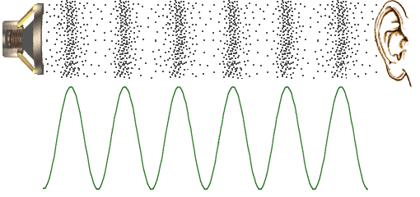

Loudness or Volume:
-Intensity or the amount of energy , determine a sounds loudness.
-Loudness is measured by a sounds amplitude.

Pitch:
-Pitch is the quality of highness or lowness in a sound. It is not loudness.
-Frequency determines pitch!

Sound Speed:
Sound speed is determined by the medium. The closer together the molecules are in a medium, the faster the sound. Think…How do particles move in matter?
-Therefore sound travels fastest in a solid . (especially elastic materials like metals)
-Sound travels second fastest in a liquid.
-Sound travels the slowest in a gas.

How Humans Hear Sound:
- Your outer ear collects vibrations into the ear canal.
- These sound waves enter the middle ear causing the eardrum to vibrate.
- The eardrum makes the middle ear bones, hammer, anvil, and stirrup, vibrate.
- These vibrations are passed onto the inner ear
- The eardrum passes these vibrations to the cochlea of the inner ear.
- Tiny hair cells in the cochlea of the inner ear vibrate.
- These hair cells send a message to the brain through the auditory nerve!

