Solutions and Mixtures
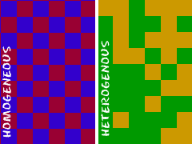
Before we dive into solutions, let's separate solutions from other types of mixtures. Solutions are groups of molecules that are mixed up in a completely even distribution. Hmmm. Not the easiest way to say it. Scientists say that solutions are homogenous systems. Everything in a solution is evenly spread out and mixed together. Other types of mixtures can have a little more of one thing (higher concentration) on one side of the liquid when compared to the other side. Let's compare sugar in water (H₂O) to sand in water. Sugar dissolves and is spread throughout the glass of water. The sand sinks to the bottom. The sugar-water could be considered a solution. The sand-water combination is a mixture.

Can anything be in a Solution?
Pretty much. Solutions can be solids dissolved in liquids. When you work with chemistry or even cook in your kitchen, you will usually be dissolving solids into liquids. Solutions could also be gases dissolved in liquids (such as carbonated water). There can also be gases in other gases, and liquids in liquids. If you mix things up and they stay at an even distribution, it is a solution. You probably won't find people making solid-solid solutions. They usually start off as solid/gas/liquid-liquid solutions and then harden at room temperature. Alloys with all types of metals are good examples of a solid solution at room temperature.
SOLUTION | EXAMPLE
Gas-Gas  Gas-Liquid  Gas-Solid  Liquid-Liquid  Liquid-Solid  Solid-Solid | Air  Carbon Dioxide (CO₂) in Soda  Hydrogen (H₂) in Palladium (Pd) Metal  Gasoline  Dental Fillings  Metal Alloys Such as Sterling Silver
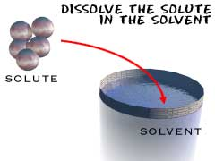
A simple solution is basically two substances that are going to be combined. One of them is called the solute. A solute is the substance to be dissolved (sugar). The other is a solvent. The solvent is the one doing the dissolving (water). As a rule of thumb, there is usually more solvent than solute. Be patient with the next sentence as we put it all together. The amount of solute that can be dissolved by the solvent is defined as solubility. That's a lot of "sol" words.
Science has special names for everything. There are names for the different types of homogenous mixtures. Solutions refer to these mixtures when the particles are very small. You may hear about colloids. Colloids are just solutions with much bigger particles. Colloids are usually foggy or milky when you look at them. In fact, milk is an emulsified colloid. You may also hear about colloids if you study soil. Milk is an organic colloid, while soils can be made up of inorganic colloids, such as clay.

Making Solutions
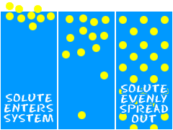
So, what happens? How do you make that solution? Mix the two liquids and stir. It's that simple. Science breaks it into three steps. When you read the steps, remember...
Solute=Sugar
Solvent=Water
System=Glass.
1. The solute is placed in the solvent and the concentrated solute slowly breaks into pieces. If you start to stir the liquid, the mixing process happens much faster.
2. The molecules of the solvent begin to move out of the way and they make room for the molecules of the solute. Example: The water has to make room for the sugar molecules to spread out.
3. The solute and solvent interact with each other until the concentration of the two substances is equal throughout the system. The concentration of sugar in the water would be the same from a sample at the top, bottom, or middle of the glass.

Can Anything Change Solutions?
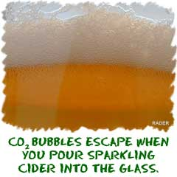
Sure. All sorts of things can change the concentrations of substances in solution. Scientists use the word solubility. Solubility is the ability of the solvent (water) to dissolve the solute (sugar). You may have already seen the effect of temperature in your classes. Usually when you heat up a solvent, it can dissolve more solid materials (sugar) and less gas (carbon dioxide). If your friend was mixing sugar and water, she would be able to dissolve a lot more sugar into hot water rather than cold.
Next on the list of factors is pressure. When you increase the surrounding pressure, you can usually dissolve more gases in the liquid. Think about your soda can. It is able to keep the fizz inside, because the contents of the can are under higher pressure. Think about a bottle of soda. The first time you open the bottle, a lot of bubbles come out. If you open and close it over a few hours, fewer and fewer bubbles will come out of the solution. When you opened the bottle the first time, you lost the high pressure that was keeping the carbon dioxide (CO₂) gas in solution.
Last is the structure of the substances. Some things dissolve easier in one kind of substance as opposed to another. Sugar dissolves easily in water and oil does not. Water has a low solubility when it comes to oil. Since oil is not soluble in water, it will never truly dissolve. Oil and water is a mixture, not a solution. The two types of molecules (oil and water) are not evenly distributed in the system.

Mixtures Around You
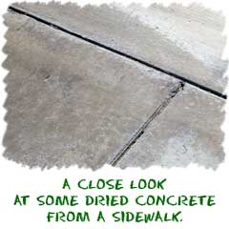
Two classic examples of mixtures are concrete and salt water. If you live near the ocean, they surround you every day. Even if you're inland, you need to remember that your tap water also has many compounds inside, and they act the same way that salt does. Concrete is a mixture of lime (CaO), cement, water(H₂O), sand, and other ground-up rocks and solids. All of these ingredients are mixed together. Workers then pour the concrete into a mold and the concrete turns into a solid (as the cement solidifies) with the separate pieces inside.
While the cement hardening might be a chemical reaction, the rocks and gravel are held in place by physical forces. They are included in the mixture to increase the strength of concrete. The rocks and gravel are not chemically bonded to the cement. The gravel is also not evenly distributed. There are pieces of gravel here and there. You may have watched building construction before. They mix the concrete for hours to try and get all the little bits mixed evenly. Even with all that mixing, the concentrations of gravel still change from area to area. Salt water is different. First, it's a liquid. Second, it's an ionic solution. Salt molecules separate into sodium (Na⁺) and chloride (Cl⁻) ions in the water.
You might be wondering why concrete and salt water are not new compounds when they are mixed together. The special trait of mixtures is that physical forces can still remove the basic parts. You can take the solid concrete and grind it up again. The individual components can then be separated and you can start all over. Salt water is even easier. All you have to do is boil the water off and the salt is left. It is as if you never mixed the two compounds. If the salt and water had reacted chemically, a new compound would have been created.

Putting Together and Breaking Apart
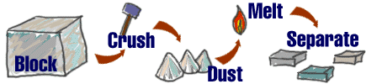
The thing to remember about mixtures is that you start with some pieces, combine them, and then you can do something to pull those pieces apart again. You wind up with the same molecules (in the same amounts) that you started with. The way you separate the molecules is as unique as the mixture. We have talked about grinding and boiling. If you have a mixture of salt and tiny pieces of iron (Fe), you can use a magnet to separate the iron from the mixture. Remember that gravity will help you separate both sand and oil from water if you wait a few minutes.

Mixture Basics
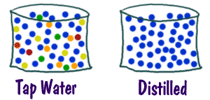
Mixtures are absolutely everywhere you look. Most things in nature are mixtures. Look at rocks, the ocean, or even the atmosphere. They are all mixtures, and mixtures are about physical properties, not chemical ones. That statement means the individual molecules enjoy being near each other, but their fundamental chemical structure does not change when they enter the mixture. If the chemical structure changed, it would be called a reaction.
When you see distilled water (H₂O), it's a pure substance. That means that there are only water molecules in the liquid. A mixture would be a glass of water with other things dissolved inside, maybe one of those powders you take if you get sick. Each of the substances in that glass keeps its own chemical properties. So, if you have some dissolved substances in water, you can boil off the water and still have those dissolved substances left over. If you have some salt (NaCl) in water and then boil off the water, the salt remains in the pan. The salt is left because it takes very high temperatures to melt salt (even more to boil it).

Mixtures are Everywhere
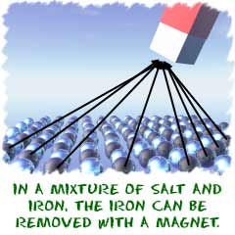
There are an infinite number of mixtures. Anything you can combine is a mixture. Think of everything you eat. Just think about how many cakes there are. Each of those cakes is made up of a different mixture of ingredients. Even the wood in your pencil is considered a mixture. There is the basic cellulose of the wood, but there are also thousands of other compounds in that pencil. Solutions are also mixtures, but all of the molecules are evenly spread out through the system. They are called homogenous mixtures.
If you put sand into a glass of water, it is considered to be a mixture. You can always tell a mixture, because each of the substances can be separated from the group in different physical ways. You can always get the sand out of the water by filtering the water away. If you were busy, you could just leave the sand and water mixture alone for a few minutes. Sometimes mixtures separate on their own. When you come back, you will find that all of the sand has sunk to the bottom. Gravity was helping you with the separation. Don't forget that a mixture can also be made of two liquids. Even something as simple as oil and water is a mixture.

