ORBIT & GRAVITY SIMULATIONS
Pre-lab
The arrows represent the amount of pulling force. For example, the picture above right shows a smiley face being pulled or attracted to the strong force of the sun. A longer arrow represents a big or strong force, and a shorter arrow represent a smaller or weaker force.
1. Based on the above information choose the picture you think shows the gravity forces on the Earth and the Sun.
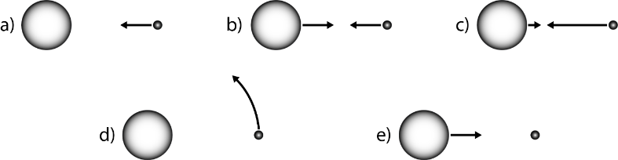

2. How would these gravity forces change if the Sun got much bigger?
Increase
Decrease
Stay the same

3. How would these gravity forces change if the Earth was much closer to the Sun?
Increase
Decrease
Stay the same

4. How would these gravity forces change if the Earth got much smaller?
Increase
Decrease
Stay the same

Use the diagram below for questions 5-7.
_____5. Choose the picture of how the Earth would move if you suddenly “turned off” the gravity forces.
_____6. Choose the letter that would demonstrate the movement if only the sun’s gravity was turned off.
_____7. Choose the letter that would demonstrate the movement if only the earth’s gravity was turned off.

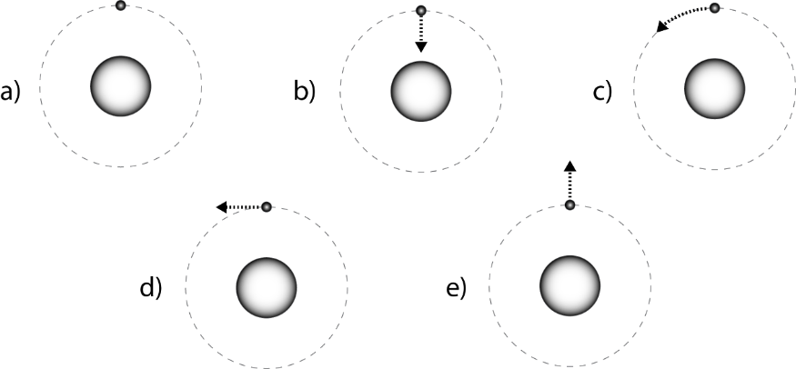

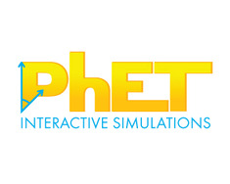
Part 1: Understanding motion
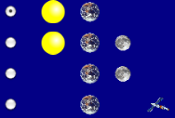
- Search PhEt Gravity and Orbits simulation.
- Download the simulation.
- Take 5 minutes to explore how the Earth, Moon, and the Space Station move. Talk about what you find with your partner.

- Compare the motion of the Earth moving around the Sun with the Moon moving around the Earth. (Be sure to turn on the path!)

Earth moves around the Sun  Your Picture | Moon moves around the Earth  Your Picture
What similarities can you find between the Earth’s movement around the sun and the moon’s movement around Earth?
____________________________________________________________________________________________________________________________________________________________________________________________________________________________________________________________________________________________________________________________________________________________________
What differences can you find between the Earth’s movement around the sun and the moon’s movement around Earth?
___________________________________________________________________________________________________________________________________________________________________________________________________________________________________________________________________________
What vocabulary word would you use to describe the shape of the orbits? ___________________________
Why would we not describe the orbits as circular? _______________________________________________
________________________________________________________________________________________

Part 2: Understanding Gravity
- For the Sun and Earth system:
Draw the path of the Earth with Gravity ON and Gravity OFF
GRAVITY ON GRAVITY OFF

- What role does gravity play in the alignment of the sun and Earth? ______________________________________________________________________________________________________________________________________________________________________________

- Draw the Sun’s gravitational pull on the Earth Draw the Earth’s gravitational pull on the Sun

Remember: A longer arrow represents a big or strong force, and a shorter arrow represent a smaller or weaker force.

- Return to your pictures in Questions 4 and add arrows to show the force of gravity. Label them with “Gravity Force”.

- Play with the sim to find ways to change the length of the blue gravity force arrows. Collect your results in the table below.
a) Fill in an ACTION below and write whether or not the gravitational force increases or decreases.
ACTION | Gravity Force Increases | Gravity Force Decreases
Increase the mass of the star
b) What has the greatest impact on gravitational forces?

- Comparisons:
a) Compare these two cases:
CASE 1 CASE 2
What was changed between Case 1 and Case 2?
Draw the force of gravity on the Earth in each case.

Extension:
Gravity Simulator: You can simulate the creation of our solar system, galaxy, universe, or black hole.
For mass input 1,000,000.
Click in the middle of the screen (there should be a red dot).
Click on different sizes (tiny to huge) and add them to the screen as well.
What happens? ___________________________________________________________________________
________________________________________________________________________________________

Clear the screen and create another red dot.
Try to get another celestial body to orbit the large one-- click, drag and release.
Watch the simulator for a few minutes. Does the orbit stay the same? _______________
What does this tell us about the orbits of the planets around the sun? _______________________________
________________________________________________________________________________________

Clear the screen and add 4 red dots.
What does this tell you about the creation of planets? __________________________________________
_______________________________________________________________________________________
Clear the screen. Add one red dot.
Try to get as many smaller dots orbiting the large dot as possible?
How many could you get? ____________
Can orbits cross without the objects smashing into one another? ________
Why do you think this happens? ____________________________________________________________
______________________________________________________________________________________
Clear the screen. Add one red dot.
Try to get as many smaller dots orbiting the large dot as possible but remain on the same (as close as possible) orbit?
What eventually happens? ________________________________________________________________

Gravity Simulator: Try to successes fully launch and land your rocket ship. What did you learn from this?

