Mysterious M&M’s I Name_______________
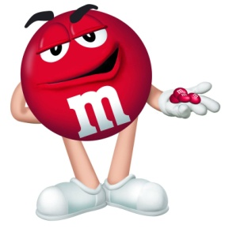
Scientists (and you) learn a lot about something by looking at it very closely or in ways you haven’t looked at it before. You may even discover things kind of by accident. Make observations (not inferences).
Step 1: Each person in your group should take one M&M and look at it closely.
Talk to your partners and discuss some of the things you observe about the M&M.
Record your observations here.
______________________________________________________________________________________________
______________________________________________________________________________________________
______________________________________________________________________________________________

Step 2: Break open the M&M and look inside.
Write what you observe in complete sentences.
_______________________________________________________________________________________________
_______________________________________________________________________________________________
_______________________________________________________________________________________________

Now make a colored illustration to show
what the inside of the M&M looks like.
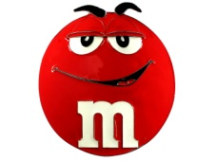

Step 3: Predict what will happen if you put an M&M of the same color in water.
What do you call a prediction made about the expected outcome of an experiment? ___________________________
Write your prediction in the form of a hypothesis.
If ________________________________________________________ then __________________________________
because __________________________________________________________________________________________
Step 4: Procedure: Carefully place an M&M in the water. Record 3 Observations:
_________________________________________________________________________________________________
_________________________________________________________________________________________________
_________________________________________________________________________________________________

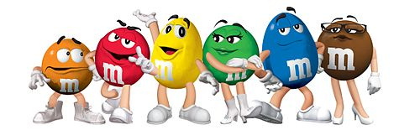
Step 5: Illustrate the change in your M&M

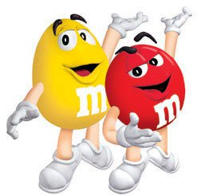
Mysterious M&M II Name_______________
Variables & Constants
-Variables are things that Change in an experiment.
-Independent variables are things the scientist changes.
-Dependent variables are things that change because of the experiment. Dependent variables are also the things being measured in an experiment.
-Constants are things that must stay the same for the experiment to work properly.
Step 1: list the variables and constants in the Mysterious M&M lab
Independent Variables ___________m&m_or m&m color_______________
Dependent Variables ________time it takes for the m&m to dissolve_______
Constants __same water, same m&m bag, containers, time we drop in the m&m_

Racing M&M’s
What color M&M will dissolve the fastest. You will place 6 M&M’s in containers and observe which color dissolves the fastest. You must get with your group to try and figure out what procedure will give you the most accurate results.
Step 2: Write your hypothesis.
If you put M&M’s in water, the ____________________ color M&M will dissolve the fastest because ______________
_________________________________________________________________________________________________

Step 3: Write an accurate Procedure.
- __________________________________________________________________________________________
- __________________________________________________________________________________________
- __________________________________________________________________________________________
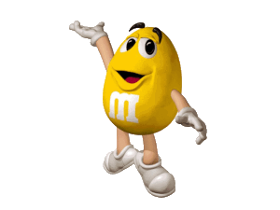
- __________________________________________________________________________________________

Step 4: Variables & Constants
What are the constants ____________________, _______________________, _____________________
What is the independent variable _________________________________
What is the dependent variable ___________________________________

Step 5: Observations
-Do certain colors seem to move faster or slower than others? _______________
-If so, which ones? __________________________________________________________________________________ If not, what did you observe? _________________________________________________________________________
_________________________________________________________________________________________________
_________________________________________________________________________________________________

Step 6: Conclusion: Explain your observations
-Did other groups have similar results? ________________________________________________________________________________________________
- Is there enough evidence from your experiments to conclude that a particular color of M&M dissolves faster in water than the others?_____ If no, explain your reasoning. _____________________________________________________
________________________________________________________________________________________________
________________________________________________________________________________________________
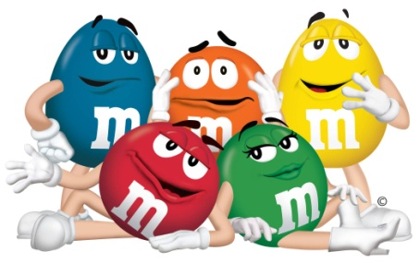
Mysterious M&M III Name_______________
Colliding or Combining
Question…
What would the color of the water look like if we placed two different M&M’s in the same container of water?
You are going to test your guess to the question above by developing a hypothesis. First you must decide which combinations of M&M colors you would like to test? Once your group decides which M&M colors to test, predict what will happen to the color of the water. Then conduct the experiment and draw your results in the circles below.
You must also draw your prediction. Be very careful when placing the M&M’s in water. Do not bump the table, or disturb the water in any way!

Step 1: Choose 4 M&M’s and develop a hypothesis for one pair of M&M’s.
If ________________________________________________________ then __________________________________
because __________________________________________________________________________________________
Step 2: Draw and color your prediction.

Step 3: Perform the experiment.
Procedure
1. Pour room-temperature water into the container so that it will cover an M&M.
2. Once the water has settled, place 2 M&M’s about 2 centimeters apart near the center of each plate. Be careful to
keep the water and M&M’s as still as possible. Observe for 3 minutes.
3. Record your observations with a colored drawing.
4. Empty the plates of water and M&M’s into a bucket, bowl, or sink, and dry them with a paper towel.

Observations:
__________________________________________________________________________________________________________________________________________________________
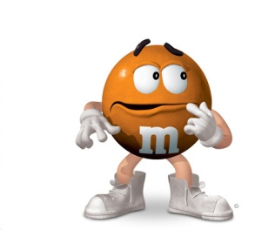
Results: Draw & color the result of your experiment.

Step 4: Write the conclusion.
Did you get the results predicted in your hypothesis? _______ To conclude you must explain your results. If your results were different from your hypothesis, you must make an inference that explains why you got these results.____________
______________________________________________________________________________________________________________________________________________________________________________________________________________________________________________________________________________________________________
__________________________________________________________________________________________________
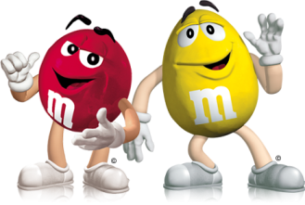
Mysterious M&M IV Name_______________
Investigating the line
Questions…
Why is there a line when 2 different colored M&M’s are placed in water?
Is the line that forms a special property of M&M’s?
Why don’t the colors mix?
The colored candy shell is dissolving into the water. What does it mean when something dissolves?

Define Dissolve
__________________________________________________________________________________________________________________________________________________________

Step 1: Perform the Experiment.
Procedure
1.Place a clear plastic container with a flat bottom on a white sheet of paper. Then pour water into the container to a
depth that would cover the M&M’s.
2. Once the water settles, place two different-colored M&M’s in the water about 2 centimeters apart.
3. Observe for 3 minutes.

Observations
1. Draw a side view of the M&M’s and their dissolved colors and write what you see.
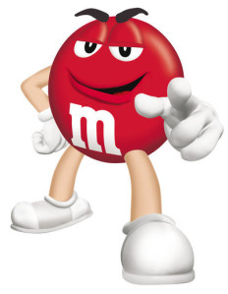
______________________________________________________
___________________________________________
___________________________________________
___________________________________________

Conclusion: Why did the colored solutions behave as they did?
_______________________________________________________________________________________________________________________________________________________________________________________________________________________________________

Step 2: Investigate That Line
The way the colored sugar solutions from M&M’s don’t mix could be something that happens only with M&M’s. But it might also happen with other candies or color substances. What else could you test to find out if non-mixing happens with other colored substances? _______________________________________________________________________

As a class you will now discuss the outer candy shell of an M&M. What is the candy shell made of?

Step 3: Answer the questions below.
-What is a solvent? __________________________________________________________________________________

-What is a solute? ___________________________________________________________________________________
-In this activity, what was the solvent? ___________________________________

-In this activity, what was the solute? ____________________________________

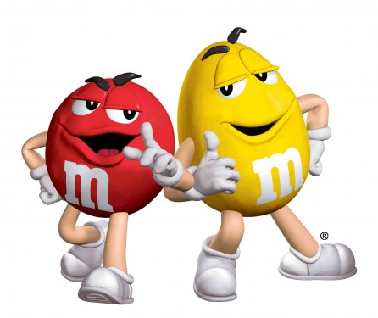
Mysterious M&M V Name_______________
testing That Line

In the following activity, you will use colored corn syrup in water the way you tested M&M’s. Like the M&M coating, the colored corn syrup is made with food coloring and sugar. Using this basic sugar solution will help you find out whether non-mixing is a property of colored sugar solutions or whether non-mixing is something that happens only with
M&M’s in water.

Step 1:
Procedure
1. Place a clear plastic container with a flat bottom on a white sheet of paper. Then pour water into the container until it
is about as deep as the water was when you tested the M&M’s.
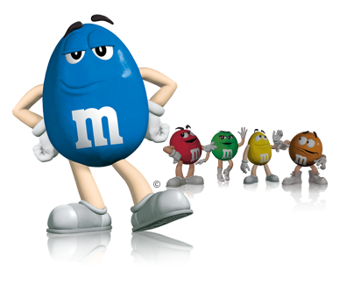
2. Once the water settles, hold the droppers with the red and blue sugar solutions upright in the container of water
about 2 centimeters apart. Then gently add about 5 drops of each solution directly beneath each dropper. When you
are done, carefully remove the droppers from the water.
Step 2:
Observations
-Observe for about 3 minutes. Look from the side and describe what you see.
-Draw a side view of the colored corn syrup in water and write what you see.
____________________________________________________
____________________________________________________
_____________________________________________________________________________

Step 3:
Conclusion
-Is the line that forms when two colors meet a special property of M&M’s?_____________________________________

-How do you know?__________________________________________________________________________________
__________________________________________________________________________________________________
__________________________________________________________________________________________________
__________________________________________________________________________________________________
-Define density______________________________________________________________________________________

-Using the term density, explain why the colors do not mix right away. _________________________________________
______________________________________________________________________________________________________________________________________________________________________________________________________________________________________________________________________________________________________

-If we left the M&M’s in water for a week, would the colors eventually mix? ____________ Why? __________________________________________________________________________________________________
__________________________________________________________________________________________________
-Do you think that the dissolved coating from gumballs or other candies with colored sugar coatings would form a line when the colors meet? _ _______________________
-What makes you think that?
__________________________________________________________________________________________________
__________________________________________________________________________________________________
__________________________________________________________________________________________________
__________________________________________________________________________________________________

