Wave Encounters! (page 27 – 28C)
When waves meet other waves this can happen…

Interference
When two or more waves come together, this can cause interference. Interference happens when waves meet and their energy is added together or their energy is taken away.

Constructive Interference
When the crests and troughs of two waves come together exactly, this can cause constructive interference. When this happens the energy of the two waves is added together.

This means that two mechanical waves with small amplitudes, can add together to make one larger wave with a greater amplitude.

Destructive Interference
When the crests of one wave joins with the trough of another wave, this can cause desstructive interference. When this happens the energy of one of the waves is subtracted from the other wave.

Two identical sound waves can even cancel each other out so you cannot hear them.

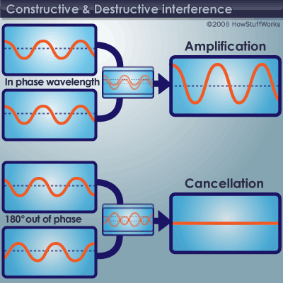

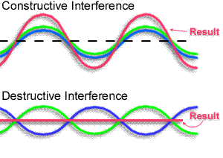

Frequency & Wavelength (page 18C)
What is the relationship?

Define Wavelength.
Wavelength is the distance from one crest to the next or one trough to the next.

Define Frequency.
Frequency is the number of waves passing a given point, in a specific amount of time.
It is usually written as waves per second. (waves / second)

Below is a wave with a frequency of 5 Waves per second!
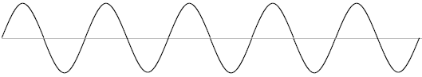
Below is that same wave with a decrease in wavelength!
What is the frequency of the wave below per second?

Answer: 10 waves per second!

When you decreased the wavelength, what happened to the frequency? The frequency increased!

What is the relationship between wavelength and frequency?
-Increase the frequency you decrease the wavelength.
-Increase the wavelength you decrease the frequency.

This is an inverse relationship. Inverse means opposite!

Thinking about frequency and wavelength…When one gets bigger the other gets smaller and when one gets smaller the other gets bigger!!

