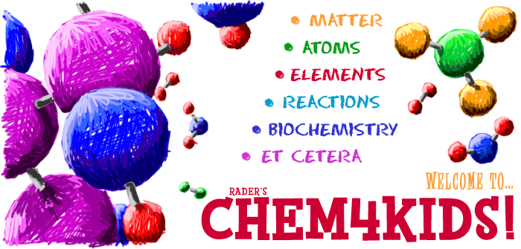
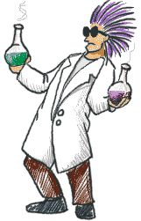
Chem4Kids General Matter Extension Lab Name___________________________
Directions:
- Type the following link in the address bar: http://www.chem4kids.com/files/matter_intro.html
- Make sure you are in the Matter section and read the information.
- As you get to the bottom of a page, click next page in Matter to go on to the next.
- Answer the following questions as you read- they are in order:
1) What is the name of the 5th state of matter that we did not study? _____________________________

2) Describe or define this 5th state of matter as best as you can. It gets easier towards the end of the description. ______________________________________________________________________________________________________________________________________________________________________________

3) Under States of matter, according to the test, when a turkey is coking, “You are able to smell the volatile compounds that are mixed in the air around you.”
-Using context clues try to define volatile as best as you can. _______________________________________________________________________________________
-Volatile has more than one definition. Look it up and write the definition that fits this text.
_______________________________________________________________________________________
Now that you understand the word volatile, does the text make more sense to you? _____________________

4) Under Plasmas in The Sun, fill in the description for plasma.
Plasmas are highly energized gases that have lost their electrons . Stars, including the Sun , are covered in plasma .

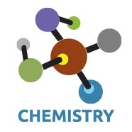
4) What needs to happen for matter to change states? (Use the Topics Column: Phase Change I)
- All matter can move from one state to another. It may require extreme temperatures or extreme
pressures.
- The text says, “Phase changes happen when you reach certain special points.”
- What did the text mean by certain special points?_______________________________________________
_______________________________________________________________________________________

5) What are the chemistry terms for the following:
Solid to a Liquid = Fusion/Melting
Liquid to a Solid = Freezing
Liquid to a Gas = Vaporization/Boiling
Gas to a Liquid = Condensation
Solid to a Gas = Sublimation
Gas to a Solid = Deposition

6) How is plasma made? (Use the Topics Column: Phase Change II) Page 2
- Plasma can be made from a gas if a lot of energy is pushed into the gas. In the case of neon, it is electrical energy that pulls the electrons off. Without the electricity to energize the atoms, the neon plasma returns to its gaseous state.
-According to the text, for a gas to phase change into a plasma, it must ionize! Click on ionize, read this entire page and write your best definition of ionize!
______________________________________________________________________________________________________________________________________________________________________________
-Do you now understand the term ionize? _______ Try and find a video, that has a more easy to understand explanation of ions, ionization, or ionize. Use your school email account to email the link to your teacher.

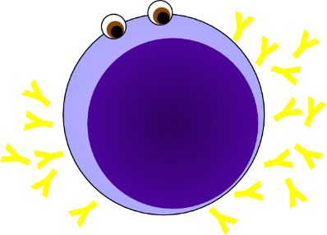
7) Play the video on the Aurora Borealis. https://youtu.be/PaSFAbATPvk\
What state of matter is the aurora? ___________________

8) What is an isomer? (Use the Topics Column: Chem-Phys)
- Isomers have the same atoms with different structures . Even though they are made of the same atoms, they have very different shapes. Isomers have atoms bonded in different orders.
- Butane and isobutene are both isomers. Their formula is as follows. $C_{6}H_{7}$NO. In the two boxes below, do
your best to draw a model of each isomer.
Butane Isobutane

10) Your body uses a chemical reaction to change galactose molecules into a kind of molecule it can
use.
- What is this molecule your body uses to get energy? Glucose

Page 3
11) What is the difference between a physical and a chemical change of matter?
(Use the Topics Column: Chem-Phys)
- Physical changes are usually about physical states of matter or phase changes.
- Write one example of a physical change. _____________________________________________________
_______________________________________________________________________________________

-Chemical changes happen on a molecular level when you have two or more molecules that interact.
Chemical changes happen when atomic bonds are broken or created during chemical reactions.
- Write one example of a chemical change. ____________________________________________________
_______________________________________________________________________________________
- Chemical Reactions (changes) occur when two or more molecules interact and the molecules
change. Bonds between atoms are broken and created to form new molecules.

If you are lost, click on the following link. http://www.chem4kids.com/files/matter_solid.html
12) What is a heterogeneous mixture? (Use the Topics Column: Solids)
- According to the text, heterogeneous mixture mixtures have different concentrations of compounds
in different areas of the mixture. Please rewrite this so it is easier to understand.
_______________________________________________________________________________________

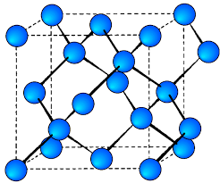

13) What is a crystal? (Use the Topics Column: Solids)
- A crystal is a form of solid where the atoms are arranged is a very specific order. The atoms
are arranged in a regular repeating pattern called a crystal lattice.

14) Wow a diamond is a special kind of crystal called an allotrope. What in the world is an allotrope?
- If the text is not very clear, try to find a very simple and clear explanation of an allotrope.
_______________________________________________________________________________________

15) What is a solution? (Use the Topics Column: Liquids)
- Different types of molecules dissolved in a liquid, it is called a solution.

16) What is happening when something is compressed? (Use the Topics Column: Liquids)
- When you compress something, you take a certain amount of material and force it
into a smaller space or volume . You force the atoms closer together.

Page 4
17) According to the text, Many shock absorbers found in cars and trucks have compressed liquids, such as oils, in sealed tubes. The shocks are called dampening device.
-Using context clues only, define dampening. _______________________________________________________________________________________
- Could you use anything else in a dampening device besides a liquid? ______________
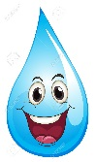
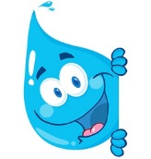
- What specific substance do you feel could be used to make superior dampening device? _______________________________________________________________________________________

18) What is cohesion? (Use the Topics Column: Liquids)
____________________________________________________________________________________________________________________________________________________________________________________________________________________
-Watch the following videos on cohesion.
https://www.youtube.com/watch?v=ynk4vJa-VaQ https://www.youtube.com/watch?v=6KKNnjFpGto
-Write a sentence that explains how you feel about the term cohesion after watching these clips.
______________________________________________________________________________________________________________________________________________________________________________

19) What is the difference between a vapor and a gas? (Use the Topics Column: Gases)
-Vapor and gas mean the same thing. The word vapor is used to describe gases that are usually liquids at room temperature.

20) What state of matter was created in 1995? (Use the Topics Column: BE Condensate)
Bose-Einstein Condensate

21) Why do we say this new state of matter can form a “super atom”? (Use the Topics Column: BE Condensate)
_______________________________________________________________________________________

22) After reading this section about all that coldness and clumping, what so you think would be the opposite state of matter of a Bose-Einstein Condensate? ______________________________________
-Please explain: __________________________________________________________________________
_______________________________________________________________________________________

23) What is an alloy? (Use the Topics Column: Mixtures II) Page 5
- An alloy is a mixture of two or more metals .

- Why would you not want to us an alloy called an amalgam to create artificial bones or hip joints?
_______________________________________________________________________________________

24) According to the text emulsions are a type of colloid. Why might someone think the example of oil and water does not seem like a colloid? You may seek out a few friends to come up with your answer. ______________________________________________________________________________________________________________________________________________________________________________

25) Fill in the chart with the missing information: (Use the Topics Column: Solutions I)
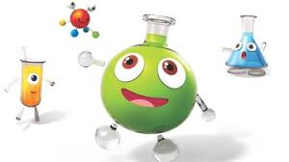
SOLUTION EXAMPLE
Gas-Gas Air
Gas-Liquid Carbon Dioxide (CO₂) in Soda
Gas-Solid Hydrogen (H₂) in Palladium (Pd) Metal
Liquid-Liquid Gasoline
Liquid-Solid Dental Fillings
Solid-Solid Metal Alloys Such as Sterling Silver

26) What is a colloid? (Use the Topics Column: Solutions I)
Colloids are solutions with bigger particles. Colloids are usually foggy or milky when you look at them. In fact, milk is an emulsified colloid.
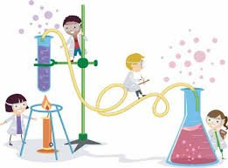

Now take some quizzes:
- Type the following into the address bar: http://www.chem4kids.com/extras/quiz_matterintro/
(General Matter Quiz) Score: ________/10
- Type the following into the address bar: http://www.chem4kids.com/extras/quiz_mattermix/index.html (Mixtures Quiz) Score: ___/10
- Type the following into the address bar: http://www.chem4kids.com/extras/quiz_mattersolution/index.html (Solutions Quiz) Score:__/10

